OPERATING SCENARIO REVIEW
Over the past ten months, BEST generated and reviewed nine scenarios representing different combinations of school facilities/grade configurations at some or all of the five schools currently owned or leased by the District: Mohawk High School/Middle School (Buckland); Buckland Shelburne Elementary School (Shelburne Falls); Colrain Central School (Colrain); Heath Elementary School (Heath), and Sanderson Academy (Ashfield). The goal was to identify which alternatives offered the highest level of operational savings vs. our existing operational configuration (i.e., Grades PK – 6 at all elementary schools and Grades 7-12 at Mohawk) while maintaining the highest possible educational quality. Each analysis was approached using the same basic assumptions, including:

Enrollment – During the winter and spring of 2016, we used actual enrollment at each grade level within each District school as of January 1, 2016, in our analyses. Beginning in the fall of 2016, scenarios selected for more in-depth analysis utilized actual enrollment as of September 1, 2016. We made no estimates of projected enrollments.

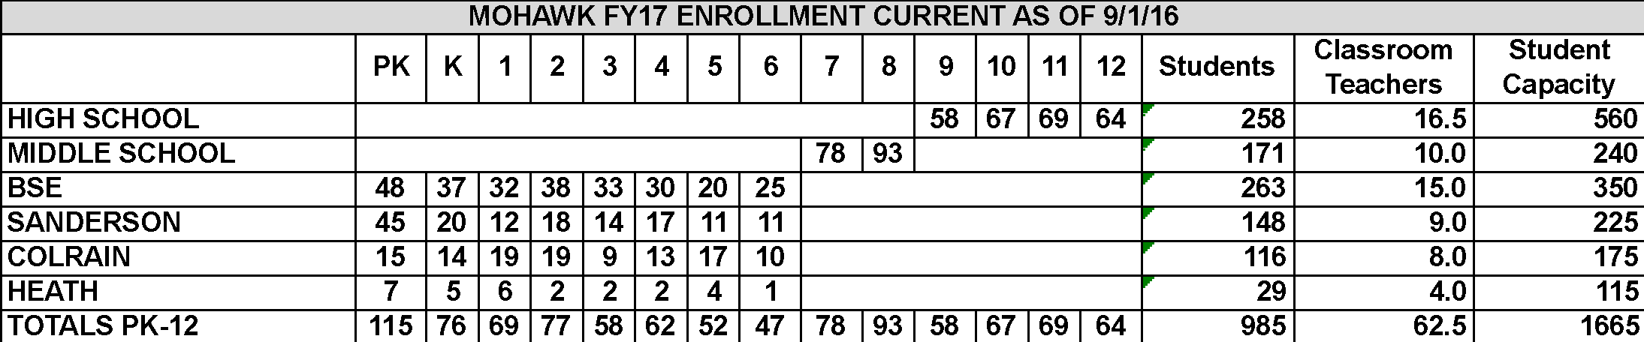

Staffing – Staffing assumptions were based on actual staffing for the 2015-16 school year (FY16). Again, to the extent scenarios were selected for more in-depth analysis, actual staffing as of September 1, 2016 was used. We then estimated the staffing that would be required to provide the current level of educational services to the current number of students, but using the alternative operational configuration being analyzed. We also accounted for the estimated increases in unemployment insurance premiums and other costs associated with staff reductions. Staffing costs (salaries and benefits) account for over 70% of the District’s annual operating budget.
Operating costs – In order to allow for an “apples to apples” comparison of operating costs, we looked at what operating costs would be given the configuration and staffing assumptions of each particular scenario and compared those costs to the budgeted costs for providing those same services under the FY 17 Mohawk District budget approved by towns. (The FY 17 budget covers period July 1, 2016 – June 30, 2017, or essentially the 2016-17 school year.)

Capital Costs – Our analysis did not include approved or anticipated capital costs, i.e., the financing of major repairs to our existing buildings or the cost of any contemplated renovations or new construction. These costs were considered separately, where appropriate, but not as part of the operating cost analyses.
Transportation – Our analysis did not project any change in transportation costs. Our existing bus contract runs through June 30, 2019. While we expect to discuss potential near-term changes with the contractor, and will continue to explore alternative transportation scenarios, we have little confidence that significant changes/reductions can be achieved prior to the end of the existing contract.

Heath – The efforts of the Heath Education Task Force, which were occurring separately but simultaneously with those of BEST, added a complicating factor. Aware that the Task Force was considering some options under which Heath’s PK-6 students would be educated outside of the MTRSD, BEST was faced with the challenge of whether to include or exclude those students (and related revenues and costs) in our own analyses. Ultimately, BEST prepared four different analyses that assumed Heath students were educated elsewhere (Scenarios #3, #3A, #4 and #7). The remaining five scenarios included Heath students. These are separately identified in the discussion that follows. Except as otherwise noted, all savings projected are gross of any costs associated with the education of Heath students outside of the MTRSD.

SCENARIOS #1 and #2
Recognizing the historical importance of our local elementary schools as centers of town civic life and culture, our first analyses were designed to determine whether any significant level of savings might be achieved if the District were to retain at least some educational presence at each existing elementary school.

Scenario #1
- Grades PK - 2 retained at all District elementary schools
- All Grades 3-5 consolidated at BSE only
- All Grades 6 transitioned to the Mohawk Middle School (Grades 6-12 at Mohawk)

Projected Operating Savings (vs. FY17 Budget): $530,000

Key Advantages:
• Keeps youngest children close to home while allowing for consolidation among other grades
• Maintains all existing schools while allowing some efficiencies
• Modest level of savings

Key Disadvantages:
• Isolation of early education professionals, with no economies of scale/sharing of resources
• Splitting of siblings among schools causes difficulty for families and younger students
• Lack of upper-grade role models for younger students
• Lack of broad-based educator support
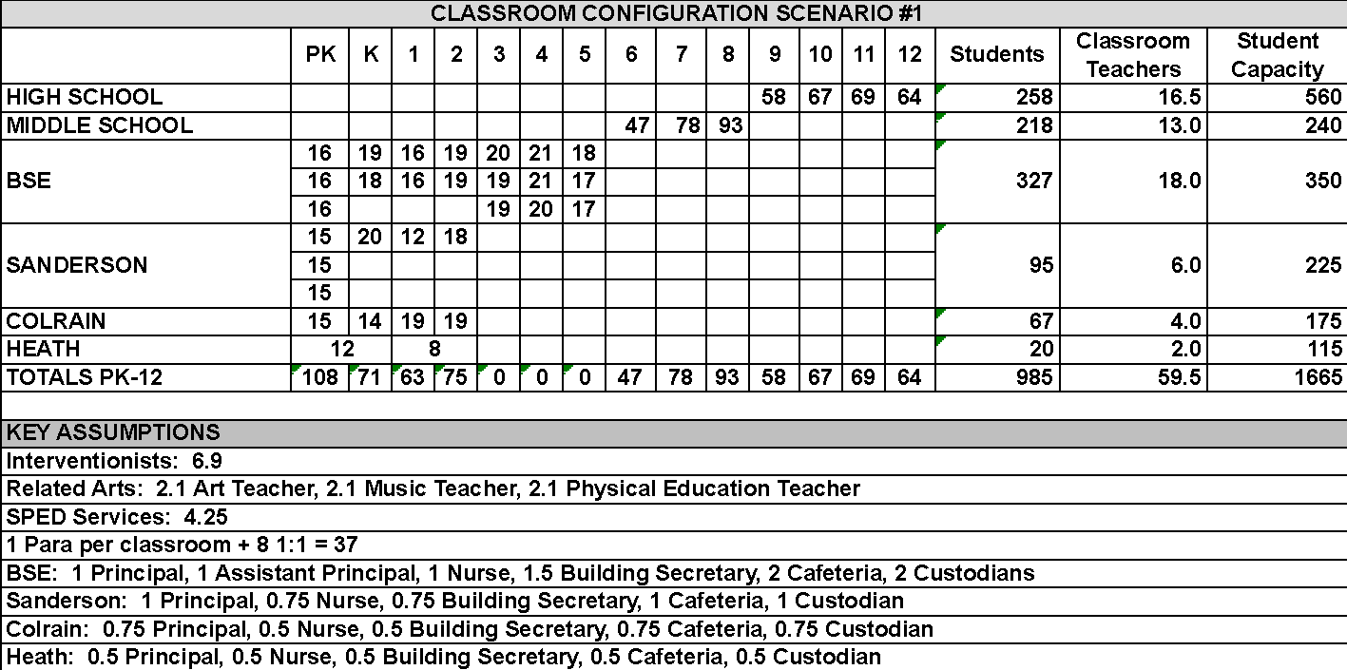

Scenario #2
- PK retained at all elementary schools
- Grades K-5 consolidated at BSE and Sanderson
- All Grades 6 transitioned to the Mohawk Middle School (Grades 6-12 at Mohawk)

Projected Operating Savings (vs. FY17 Budget): $680,000

Key Advantages:
• Keeps very youngest children close to home while allowing for consolidation among other grades
• Maintains some educational presence at all existing schools
• Medium level of savings

Key Disadvantages:
• Isolation of PK professionals and viability of a “true” PK program vs. “daycare”
• Splitting of siblings among schools causes difficulty for families and younger students
• Lack of upper-grade role models for younger students
• Virtually no support among educators for PK-only options

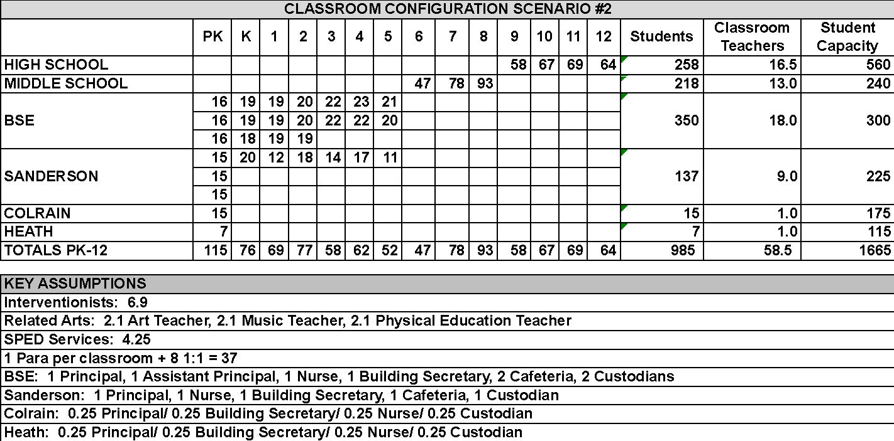

Conclusion: Scenarios #1 and #2 – Not recommended

After reviewing these options, the Committee was unable to support keeping even a reduced educational presence at all schools. The amount of savings generated through consolidation of only certain grades is insufficient, particularly under Scenario #1, and would be quickly consumed by rising costs within only a few years. While retention of a PK-only program at all schools generated slightly more savings, educators were overwhelmingly opposed to separating PK from other elementary grades. The District has developed an effective PK program that goes well beyond simple “daycare,” and key elements of this program rely on positive interaction between PK students and their older counterparts, as well as resource sharing and collaboration among PK and elementary educators.

SCENARIOS #3, #4 and #7

Contemporaneous with the efforts of the BEST Committee, the Heath Education Task Force was working to assess various options for educating Heath’s PK-6 students. In late November 2016, after considering a variety of options, the Heath Education Task Force has chosen to pursue a plan under which (1) the Heath Elementary School would close, (2) Heath would remain a PK-12 member of the Mohawk District (and would continue to send its Grade 7-12 students to Mohawk), and (3) Heath's PK-6 students would attend (one of) Hawlemont Elementary or Rowe Elementary under a tuition agreement negotiated between the Mohawk District and Hawlemont or Rowe. Heath would continue to pay its operating assessment to the MTRSD and Mohawk would pay tuition for Heath students to the receiving school. The Mohawk District and the Town of Heath are currently discussing the feasibility of such an arrangement, which would require the approval of all District Towns, as well as the Massachusetts Department of Elementary and Secondary Education (DESE).

Aware of the ongoing efforts of the Heath Task Force, the BEST Committee developed Scenarios #3, #4 and #7 to assess the impact of a potential decision by Heath to educate the town’s PK-6 students outside of the District. Each of these scenarios was designed to determine what level of elementary programs (PK-only, PK-2 or PK-5) might sustainably be operated at BSE, Sanderson and or Colrain if the Heath School were closed and Heath’s elementary students were to exit the District. The financial impact of educating Heath’s PK-6 students outside of the District was considered in these analyses.

Scenario #3
- Heath School closes and Heath elects to send the town’s PK-6 students outside the District
- PK only remains at Colrain
- BSE and Sanderson offer PK - 5
- All Grades 6 students transition to the Mohawk Middle School (Grades 6-12 at Mohawk)

Projected Operating Savings (vs. FY17 Budget): $968,000, less tuition costs for Heath students

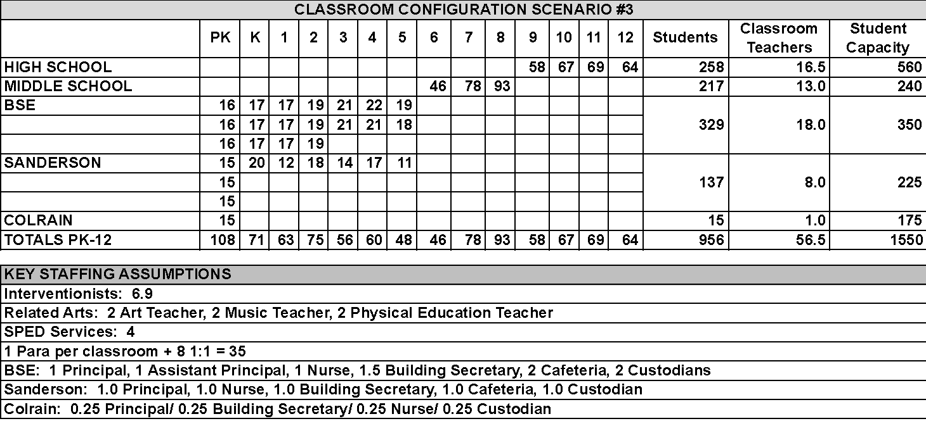Key Advantages:
• Keeps very youngest Colrain children close to home while allowing for upper grade consolidation
• Maintains some educational presence in Colrain
• Potentially attractive level of savings, offset by the cost of educating Heath students outside of the District

Key Disadvantages:
• Isolation of PK professionals and viability of a “true” PK program in Colrain vs. “daycare”
• Lack of upper-grade role models for younger Colrain students
• Virtually no support among educators for PK-only options

Scenario #4
- Heath School closes and Heath elects to send the town’s PK-6 students outside the District
- Grades PK to 2 only at Sanderson and Colrain
- BSE offers PK - 2 and consolidated Grades 3-5
- All Grades 6 students transition to the Mohawk Middle School (Grades 6-12 at Mohawk)

Projected Operating Savings (vs. FY17 Budget): $1,000,000, less tuition costs for Heath students

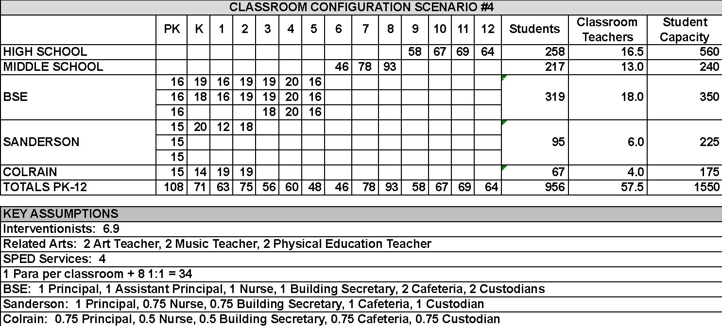

Key Advantages:
• Keeps youngest children close to home while allowing for consolidation among other grades
• Maintains educational presence at Colrain and Sanderson while allowing some efficiencies in higher grades
• Potentially attractive level of savings, offset by the cost of educating Heath students outside of the District

Key Disadvantages:
• Isolation of early education professionals, with no economies of scale/sharing of resources
• Splitting of siblings among schools difficult for families and students
• Lack of upper-grade role models for younger students at Colrain and Sanderson

Conclusion: Scenarios #3 and #4 – Not recommended

Our review of these options indicated that while the savings generated were potentially higher that the savings under Scenarios #1 and #2, Scenarios #3 and #4 suffered from the same issues as those options: the inherent disadvantages from an educational perspective, of segregating the lower and upper elementary grades. Given these disadvantages, particularly as strongly expressed by the District’s elementary educators, we felt other options provided similar savings with fewer educational disadvantages.

Scenario #7
- Heath School closes and Heath elects to send the town’s PK-6 students outside the District
- Grades pre-K to 5 remain at Colrain, Sanderson and BSE
- All Grades 6 students transition to the Mohawk Middle School (Grades 6-12 at Mohawk)

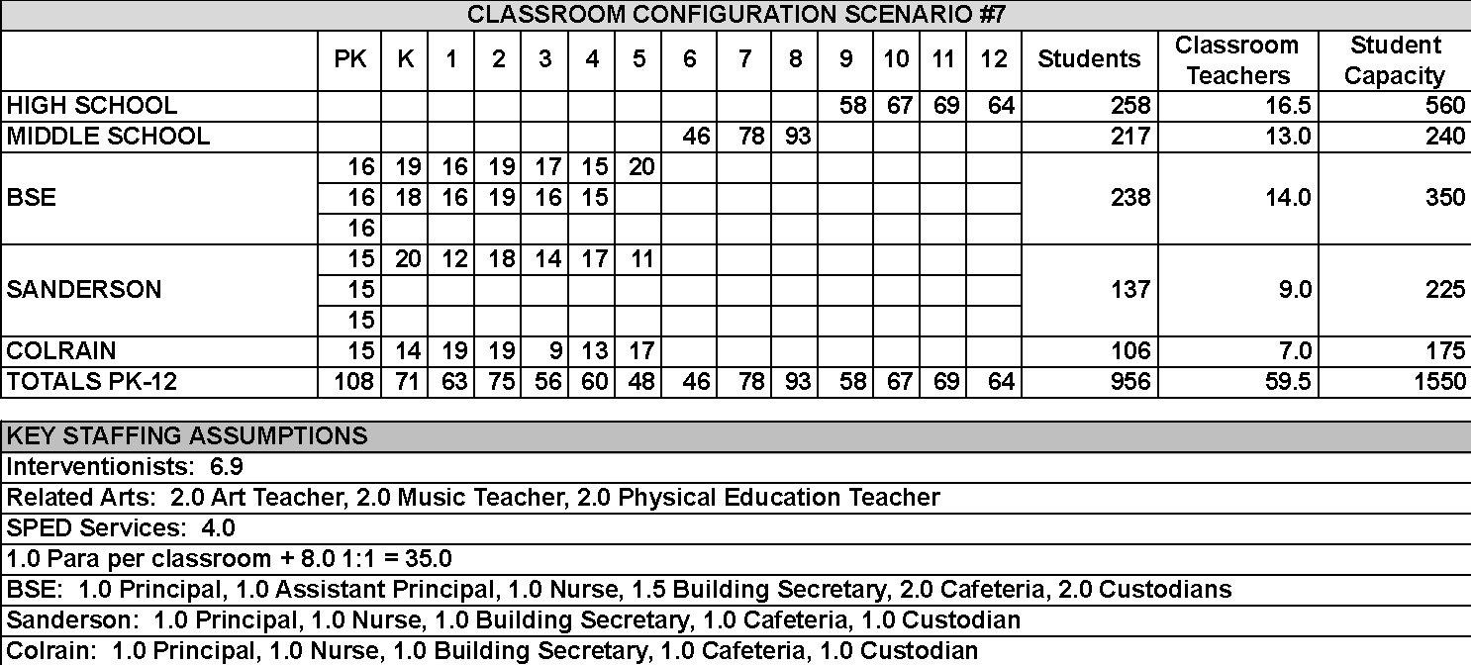

Projected Operating Savings (vs. FY17 Budget): $682,000, less cost of tuition for Heath students

Key Advantages:
• Maintains strong educational presence at all remaining elementary schools
• Avoids potential splitting of siblings into different schools

Key Issues:
• Limited savings relative to other options
• No long-term economies of scale

Conclusion: Not Recommended

Because a preliminary analysis of this scenario indicated limited savings, it was not reviewed in depth. It was clear that the closure of Heath alone, combined with consolidation of Grade 6 students at Mohawk, would not produce sufficient savings to have a meaningful impact on the District’s sustainability.

The next step in our process was to assess the impact of closing Colrain Central School in combination with a decision by Heath to educate its PK-6 students outside of the District. In essence, this Scenario is the same as Scenario #3, but without maintaining a PK presence in Colrain.

SCENARIO #3A
- Heath School closes and Heath elects to send the town’s PK-6 students outside the District
- Colrain Central School closes
- All Grades PK to 5 consolidated at BSE and Sanderson
- All Grades 6 students transition to the Mohawk Middle School (Grades 6-12 at Mohawk)

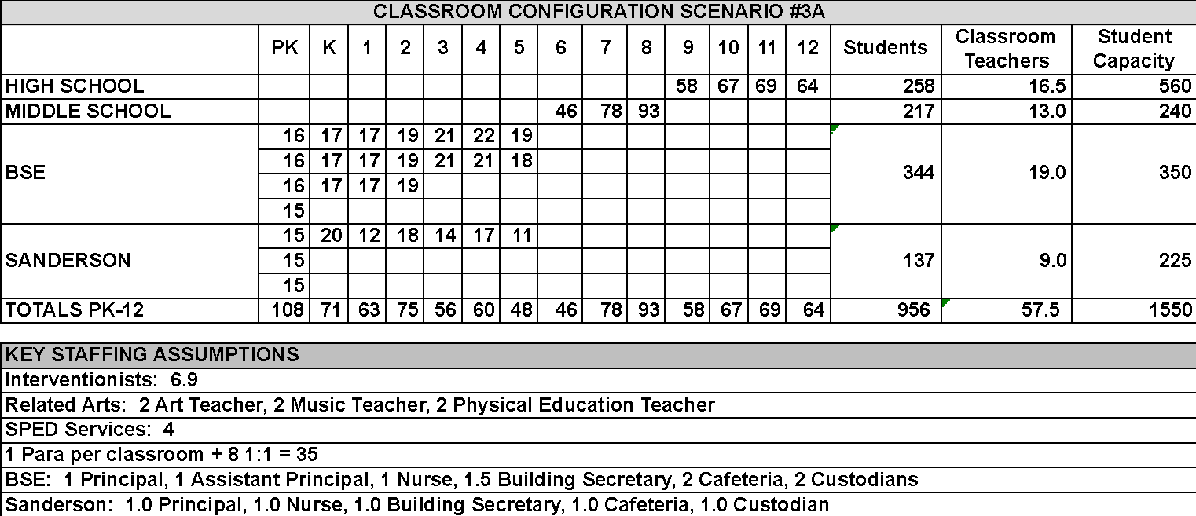

Projected Operating Savings (vs. FY17 Budget): $1,200,000, less the cost of tuition for Heath students

Key Advantages:
• Achieves greater efficiencies of scale by consolidating all PK-5 students into two elementary schools
• Attractive level of savings

Key Issues:
• Colrain loses its local school
• Additional transition for some students
• Potential capacity constraints at BSE

Conclusion: Recommended as a potential Phase 3

Scenario #3A offers an attractive level of savings, created through the consolidation of Grades PK-5 into two locations. Because of capacity limitations at BSE, the District’s largest and most centrally located elementary school, this consolidation would not be possible without the expanding the Mohawk Middle School to include 6th grade.

BEST also believes this Scenario offers the potential to achieve some additional savings in transportation if, in cases where there is a clear financial benefit and reduced time on bus, elementary students were assigned to the school closest to their home, regardless of town lines. (These potential savings have not been included in Potential Operating Savings, above.) Therefore, BEST voted to recommend Scenario #3A as Phase 3 of the sustainability plan.

SCENARIO #5
- All Grades pre-K to 5 consolidated into a newly constructed centralized facility (or wing) on the Mohawk campus
- All Grades 6 students transition to the Mohawk Middle School (Grades 6-12 at Mohawk)

Projected Operating Savings (vs. FY17 Budget): $1,230,000*
*This scenario assumed Heath students (PK-12) continue to be educated in District schools.

Key Advantages:
• Maximizes efficiency of staffing resources by consolidating all grades and student services into a single location
• State-of-the-art infrastructure and operating systems (e.g., heating, lighting) will minimize ongoing operational expenditures
• All towns “share the pain” of closing elementary schools
• Very attractive level of savings

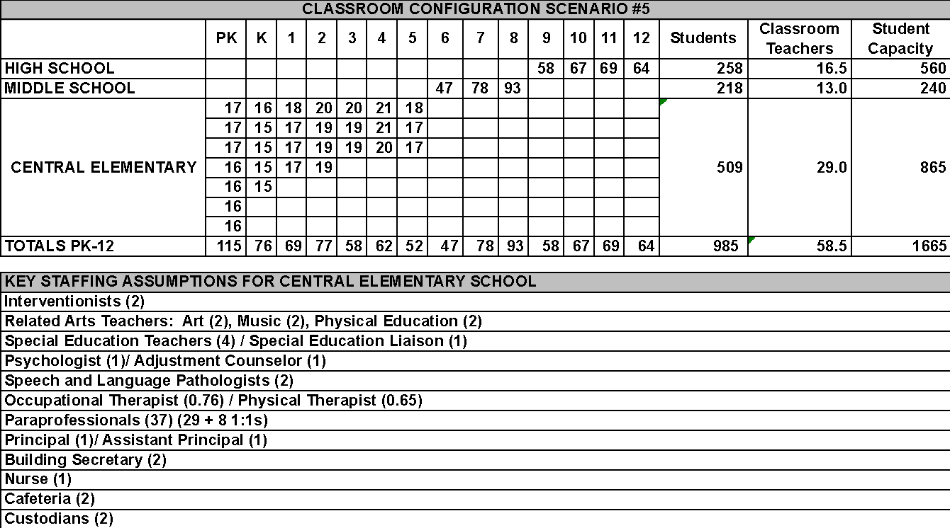
Key Disadvantages:
• Member towns’ ability to finance the District’s portion of construction costs
• Likelihood and amount of MSBA financing is unknown
• Potential requirement to repay a portion of MSBA contributions to existing facilities

Conclusion: Recommended as a potential Phase 4, subject to further feasibility analysis

The BEST Committee believes that over the long term, the most financially efficient and educationally advantageous path toward sustainability would be to centralize all levels of educational programming in a single location on the existing Mohawk campus. Doing so would require the construction of a new school (or wing) for elementary grades PK-5.

The advantages to students of consolidating educational resources and programming are many, as are the operating efficiencies. However, in order to more thoroughly understand the costs of constructing a centralized elementary school, BEST’s Finance & Facilities Subcommittee will seek School Committee approval to complete a thorough feasibility study of centralized options prior to December 31, 2017. We intend the review to consider not only construction of a new, separate school at Mohawk, but also viable alternative options, such as adding a new elementary wing at Mohawk or renovating and expanding BSE, which could be less costly. We will begin shortly to explore ways to fund this critical effort. It will not be funded out of the Mohawk operating budget.

SCENARIO #6
- Grades PK to 5 at BSE, Heath, Colrain and Sanderson
- BSE also becomes a Middle School for all Grades 6 to 8
- Mohawk retains Grades 9-12, using former Middle School space for expanded career/ vocational programs

Projected Operating Savings (vs. FY17 Budget): Preliminary Analysis $250,000 – $300,000*
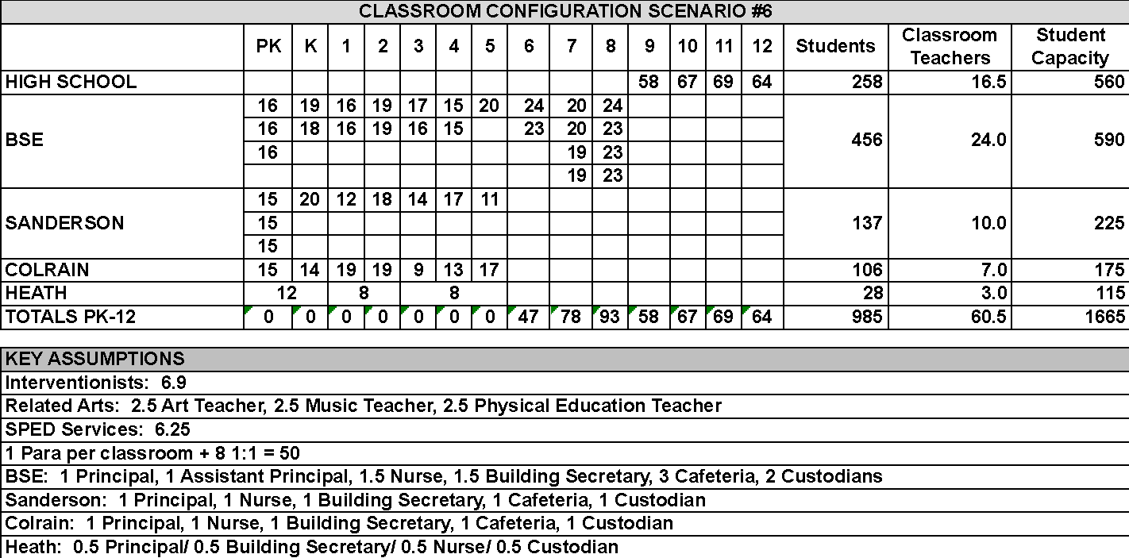

Key Advantages:
• Creation of a true, separate Middle School offers educational advantages
• Allows for enhanced career programming at Mohawk to attract/retain “hands-on” learners
• Maintains significant educational presence at all other elementary schools

Key Issues:
• Insignificant savings relative to other options
• BSE lacks sufficient capacity to house a consolidated Grade 6-8 middle school in additional to a PK-5 program
• Existing BSE lacks key middle school requirements such as gym space, locker rooms, etc.
• Ability to create vocational program that generates revenue at Mohawk not guaranteed

Conclusion: Not Recommended

The BEST Committee considered this option as intuitively attractive because it offered a way to gain the educational benefits offered by a true middle school for Grades 6-8 as well as to provide an expanded vocational and career-training curriculum for Grades 9-12. However, it very quickly became apparent that even the largest of the existing elementary buildings (BSE) lacks the capacity to house both an elementary school and a new middle school. In addition, substantial renovation would be necessary to create gymnasium space, locker rooms, appropriate bathrooms and other features required to meet the needs of middle school students.

SCENARIO #8
- All Grades PK-5 at renovated/expanded BSE
- All Grades 6 students transition to the Mohawk Middle School (Grades 6-12 at Mohawk)

Projected Savings (vs. FY17 Budget): $1,000.000 (preliminary)

Key Advantages:
• Enhances efficiency of staffing resources by consolidating all elementary grades and student services into a single location
• Very attractive level of savings
• Potentially less expensive than constructing a completely new facility at Mohawk
• Renovation could partially or wholly replace old infrastructure with state-of-the-art systems (e.g., heating, lighting) to minimize long-term operational expenditures

Key Issues:
• Renovation costs
• Existing structural issues BSE may make renovation more expensive than new construction
• Likelihood and amount of MSBA financing is unknown
• Potential requirement to repay a portion of MSBA contributions to existing facilities

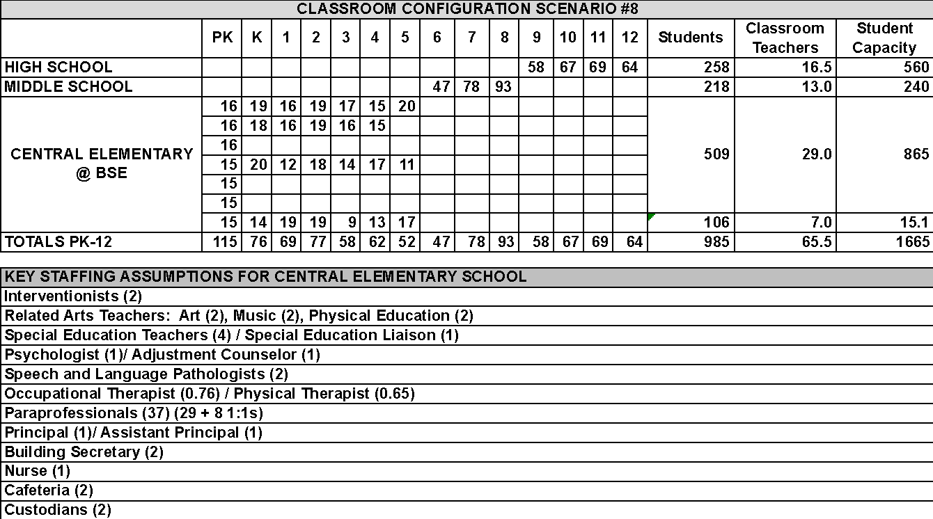

Conclusion: Not Recommended, subject to further feasibility analysis

The BEST Committee considered this option as an alternative to Scenario #5 (building a new centralized elementary school on the Mohawk campus). Our initial analysis indicated that the projected operating savings were slightly lower than under Scenario #5. In addition, renovation/reconstruction of BSE would entail all of the potential downsides of constructing a new facility at Mohawk (e.g., the uncertainty of MSBA funding, affordability for District Towns) and the additional uncertainties inherent in renovating an almost 60-year old building. Furthermore, two architects familiar with the building offered the opinion that building a new facility (at Mohawk or at BSE) would likely be less expensive than trying to renovate the existing structure. Consequently, the BEST Committee voted to recommend Scenario #5 rather than Scenario #8. However, as part of our assessment of the feasibility of a centralized elementary facility, it is our intention to look more in depth at the relative costs of renovation at BSE vs. new construction at Mohawk.

SCENRIO #9
- All Grades PK-2 at one Early Learning Center (BSE)
- All Grades 3-5 consolidated at Sanderson
- All Grades 6 students transition to the Mohawk Middle School (Grades 6-12 at Mohawk)

Projected Savings (vs. FY17 Budget): $1,100,000

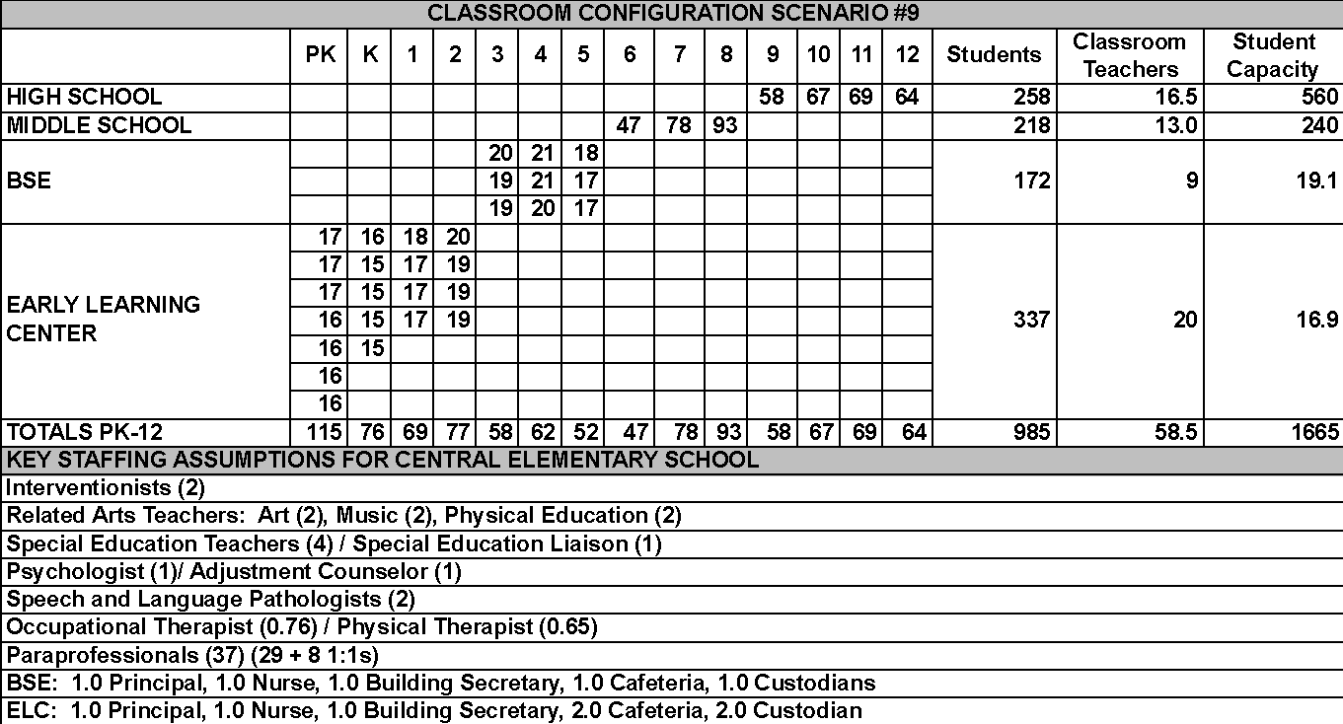

Key Advantages:
• Consolidated facility focused solely on early learning allows for maximum sharing of professional skills and resources
• Very attractive level of savings
• An Early Learning Center may be attractive to out-of-District parents as the only facility of its kind in the area

Key Issues:
• Higher transportation costs and potential time-on-bus issues
• Splitting of siblings among schools difficult for families and students
• Lack of upper-grade role models for younger students

Conclusion: Not Recommended
This Scenario also offers an attractive level of operational savings. However, the BEST Committee voted not to recommend this option for several reasons. First, the only District elementary school with sufficient space to accommodate all PK-2 students is BSE. Thus all Grade 3-5 students would be educated at Sanderson (the District’s second largest elementary school), leading to potential time-on-bus issues for students in the more distant reaches of the District. More importantly, PK-2 options in any configuration received little support from the District’s elementary educators. While many saw potential advantages to the concept of an early learning center dedicated to PK-2 (or PK-3) students, they felt these were more than outweighed by the loss of regular interaction with upper elementary students; the potential hardship on families with students in both lower and upper elementary grades; and the likely weakening of PTOs and other parent volunteer efforts that have been important to maintaining the District’s strong elementary schools. The concept of a consolidated early learning center remains attractive and could be integrated into any plan to construct or renovate a centralized elementary campus.

